Children’s Center Day Care
Menu for the Week of
October 27th – October 31st, 2025

FALL/WINTER  WEEK 1 | MONDAY | TUESDAY | WEDNESDAY | THURSDAY | FRIDAY
BREAKFAST  9:30-10:00 | Crisp Rice Cereal  Diced Pears  Milk* | Honey Bunches of Oats†  Bananas  Milk* | Oatmeal†  Diced Peaches  Milk* | Rice Chex Cereal†  Apples  Milk* | Toasted Wheat Bagels†  Peaches, Pears or Apples  Milk*
LUNCH  11:30-12:00 | Chicken Tenders°  Green Beans  Whole Wheat Bread†  Apples  Milk* | Noodle Kugel (Baked  Egg Noodles with  Cheese and Egg)  Peas  English Muffins  Pineapple Tidbits  Milk* | Taco Mac and Cheese with Ground Turkey°  Corn  Buttermilk Biscuits  Grapes  Milk* | Chicken° and Cheese Burritos on Flour Tortillas  Mixed Vegetables  Taco Chips  Honeydew  Milk* | Tomato Soup  Cheese Sandwiches on  Whole Wheat Bread†  Carrot Sticks‡  Clementines  Milk*
SNACK  varies by class  served between  2:45 and 3:45 | Strawberry Yogurt  Goldfish Grahams†  Water | Baked Oyster Crackers with Ranch Seasoning  Grape Juice | Club Crackers  Onion Chive  Cream Cheese  Apple Juice | Banana Chocolate  Chip Bread  Milk* | Whole Grain  Goldfish Crackers†  Apple or Grape Juice

* Children under 2 years of age will be served whole milk. Children over 2 years of age will be served 1% or skim milk. All milk served is unflavored.
† Denotes a whole grain or whole grain rich food.
° Or appropriate meat substitute

Children’s Center takes part in the Child and Adult Care Food Program through the U.S. Department of Agriculture. We are an equal opportunity provider.
Children’s Center Day Care
Menu for the Week of
November 3rd – 7th, 2025

FALL/WINTER  WEEK 2 | MONDAY | TUESDAY | WEDNESDAY | THURSDAY | FRIDAY
BREAKFAST  9:30-10:00 | Corn Flakes Cereal†  Diced Peaches  Milk* | Baked Triscuits†  with Cheese  Peaches, Pears or Apples  Milk* | Baked French Toast  Applesauce  Milk* | Corn Chex Cereal†  Diced Pears  Milk* | Life Cereal†  Bananas  Milk*
LUNCH  11:30-12:00 | Baked Scrambled Eggs  with Diced Ham°  Green Beans  English Muffins  Bananas  Milk* | Sloppy Joes° on a  Whole Wheat Bun†  Mixed Vegetables  Pineapple Tidbits  Milk* | Chicken° Noodle Soup with Peas and Carrots  Cheese Cubes  Oyster Crackers  Grapes  Milk* | Chicken° Curry Casserole  White Rice  Carrots  Pita Crackers  Honeydew  Milk* | Macaroni and Cheese  with Turkey Sausage°  Corn  Buttermilk Biscuits  Apples  Milk*
SNACK  varies by class  served between  2:45 and 3:45 | Bagels and  Cream Cheese  Grape Juice | Whole Grain Goldfish Crackers †  Grapes  Milk* | Apple Yogurt Muffins  Apple Juice | Clementines  Wheat Thins†  Water | Cheez-Its  Apple or Grape Juice

* Children under 2 years of age will be served whole milk. Children over 2 years of age will be served 1% or skim milk. All milk served is unflavored.
† Denotes a whole grain or whole grain rich food.
° Or appropriate meat substitute

Children’s Center takes part in the Child and Adult Care Food Program through the U.S. Department of Agriculture. We are an equal opportunity provider.
Children’s Center Day Care
Menu for the Week of
November 10th – 14th, 2025

FALL/WINTER  WEEK 3 | MONDAY | TUESDAY | WEDNESDAY | THURSDAY | FRIDAY
BREAKFAST  9:30-10:00 | Crispix Cereal†  Diced Pears  Milk* | Crisp Rice Cereal  Diced Peaches  Milk* | Toasted Wheat Bagels†  Apples  Milk* | Soy Butter Quesadillas  on Flour Tortillas  Bananas  Milk* | Buttermilk Biscuits  Peaches, Pears or Apples  Milk*
LUNCH  11:30-12:00 | Bean and Cheese Burritos  on a Flour Tortilla  Mixed Vegetables  Tortilla Chips  Grapes  Milk* | Barbeque Meatballs°  Mashed Potatoes  Peas  Whole Wheat Bread†  Pineapple Tidbits  Milk* | Salsa Chili with Beans  and Ground Turkey°  Carrot Sticks  Oyster Crackers  Clementines  Milk* | Tuna Boats (Baked  Tuna Salad° and Cheese on a Hot Dog Bun)  Mixed Vegetables  Cheez-Its  Honeydew  Milk* | Turkey Dogs° on a  Whole Wheat Bun  Green Beans  Tater Tots  Clementines  Milk*
SNACK  varies by class  served between  2:45 and 3:45 | Fresh Fruit Assortment  (Bananas, Apples, Clementines)  Triscuit Minis†  Water | Cottage Cheese  Pretzels  Apple Juice | Sweet Potato Cake  Milk* | Kix and Pretzel  Snack Mix†  Grape Juice | Scooby Snacks†  Apple or Grape Juice

* Children under 2 years of age will be served whole milk. Children over 2 years of age will be served 1% or skim milk. All milk served is unflavored.
† Denotes a whole grain or whole grain rich food.
‡ Children under the age of 2 years will not be served raw carrots. Cooked carrots will be offered instead.
° Or appropriate meat substitute

Children’s Center takes part in the Child and Adult Care Food Program through the U.S. Department of Agriculture. We are an equal opportunity provider.
Children’s Center Day Care
Menu for the Week of
November 17th – 21st, 2025

FALL/WINTER  WEEK 4 | MONDAY | TUESDAY | WEDNESDAY | THURSDAY | FRIDAY
BREAKFAST  9:30-10:00 | Corn Flakes Cereal†  Diced Pears  Milk* | Kix Cereal†  Bananas  Milk* | Oatmeal†  Diced Peaches  Milk* | Cinnamon Bread  Applesauce  Milk* | English Muffins  Peaches, Pears or Apples  Milk*
LUNCH  11:30-12:00 | White Bean Tomato Soup  White Rice  Cheese Cubes  Carrot Sticks  Apples  Milk* | Chicken° Taco Salad  Corn  Taco Chips  Clementines  Milk* | Penne Pasta w/ Chicken°,  Cheese and Broccoli  Green Beans  Grapes  Milk* | Southwestern Rice  with Ground Turkey°  Mixed Vegetables  Buttermilk Biscuits  Honeydew  Milk* | Roasted Turkey Sausage°  Roasted Red Potatoes  Carrots  Whole Wheat Bread†  Pineapple Tidbits  Milk*
SNACK  varies by class  served between  2:45 and 3:45 | Whole Wheat Ritz Crackers†  Soy Butter  Milk* | Bananas  Animal Crackers  Water | Carrot Zucchini Muffins  Milk* | Sun Chips†  Grape Juice | Pretzels  Cheese Cubes  Apple or Grape Juice

* Children under 2 years of age will be served whole milk. Children over 2 years of age will be served 1% or skim milk. All milk served is unflavored.
† Denotes a whole grain or whole grain rich food.
‡ Children under the age of 2 years will not be served raw carrots. Cooked carrots will be offered instead.
° Or appropriate meat substitute

Children’s Center takes part in the Child and Adult Care Food Program through the U.S. Department of Agriculture. We are an equal opportunity provider.
Children’s Center Day Care
Menu for the Week of
November 24th – 28th, 2025

FALL/WINTER  WEEK 5 | MONDAY | TUESDAY | WEDNESDAY | THURSDAY | FRIDAY
BREAKFAST  9:30-10:00 | Frosted Mini  Wheats Cereal†  Diced Peaches  Milk* | Toasted Oats Cereal†  Diced Pears  Milk* | Pork Sausage and  Cheese Biscuits  Apples  Milk* | 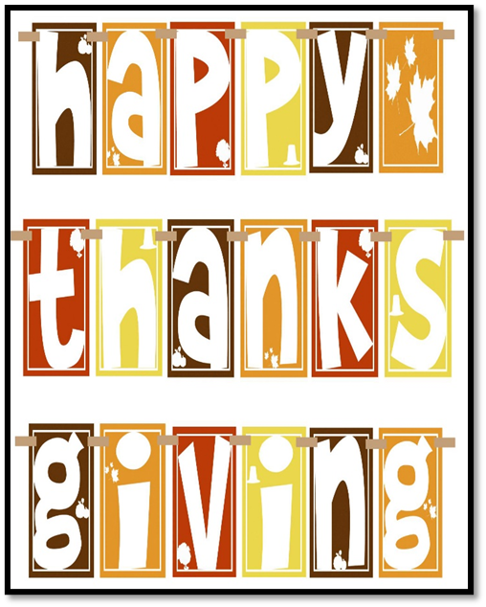
LUNCH  11:30-12:00 | Cheesy Breadsticks with  Marinara Sauce  Carrots  Honeydew  Milk* | Turkey  Mashed Potatoes  Green Beans  Cranberries  Rolls  Milk* | Cheese Pizza  Green Beans  Grapes  Milk*
SNACK  varies by class  served between  2:45 and 3:45 | Graham Crackers  Bananas  Water | Pumpkin Pie  Milk* | Cucumber and Cream Cheese on White Bread  Apple Juice

* Children under 2 years of age will be served whole milk. Children over 2 years of age will be served 1% or skim milk. All milk served is unflavored.
† Denotes a whole grain or whole grain rich food.
° Or appropriate meat substitute

Children’s Center takes part in the Child and Adult Care Food Program through the U.S. Department of Agriculture. We are an equal opportunity provider.

